Task 1: Personal Loan Acceptance Prediction

1. Introduction:
Personal loan acceptance prediction is a machine learning task in which we predict whether a customer will accept a loan offer or not. This helps banks and financial institutions target the right customers and improve marketing efficiency.
In this task, we used the Bank Marketing dataset to analyze customer information and build predictive models.

2. Objective:
The main objective of this task is:
- To analyze customer data
- To predict whether a customer will accept a personal loan offer
- To identify which type of customers are more likely to accept the offer

3. Dataset Description:
The dataset used is the Bank Marketing dataset. It contains customer-related information such as:
- Age
- Job
- Marital status
- Education
- Balance
- Contact type
- Previous campaign outcome
The target variable is:
- y (yes/no) → whether the customer accepted the loan offer

4. Data Exploration (EDA):
In the data exploration phase:
- We checked the shape and structure of the dataset
- Used functions like .info() and .describe()
- Visualized the target variable using count plots
From the analysis:
- Most customers did not accept the offer
- Data is imbalanced (more "no" than "yes")

5. Data Preprocessing:
Before training the model, we performed preprocessing:
- Converted target variable (yes/no → 1/0)
- Applied Label Encoding on categorical features
- Split dataset into training and testing sets

6. Model Building:

6.1 Logistic Regression
Logistic Regression is a classification algorithm used for binary outcomes.
- Simple and fast model
- Works well for linearly separable data

6.2 Random Forest
Random Forest is an ensemble learning method.
- Uses multiple decision trees
- Gives better accuracy
- Handles complex patterns

7. Model Evaluation
We evaluated models using:
- Confusion Matrix
- Classification Report (Precision, Recall, F1-score)
- ROC Curve and AUC score
Results showed:
- Random Forest performed better than Logistic Regression
- It achieved higher accuracy and F1-score
CODE:
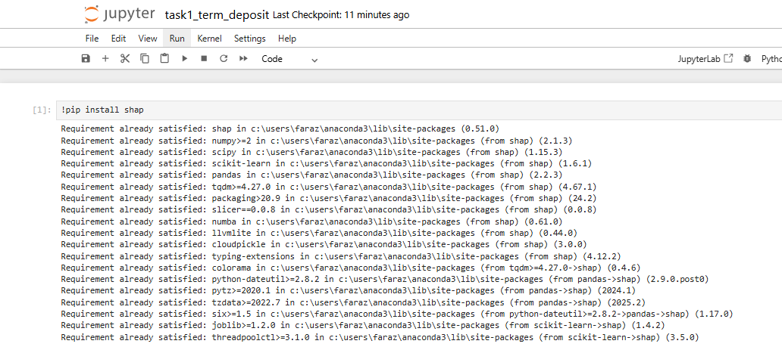
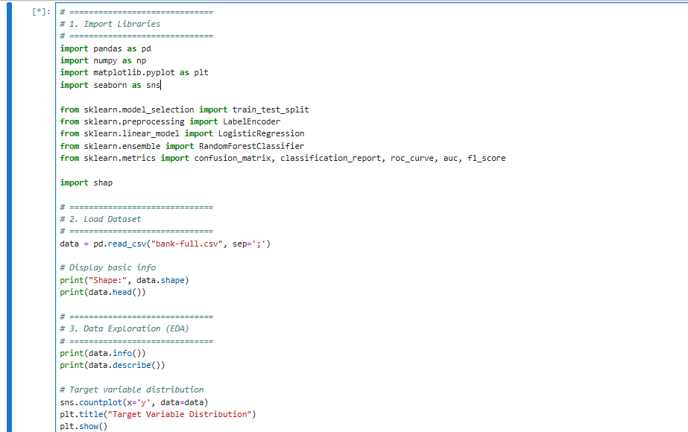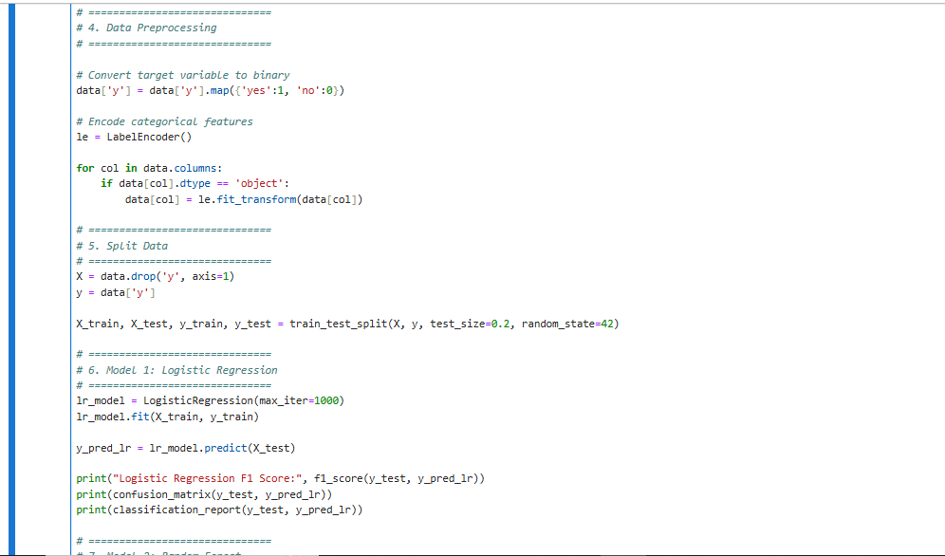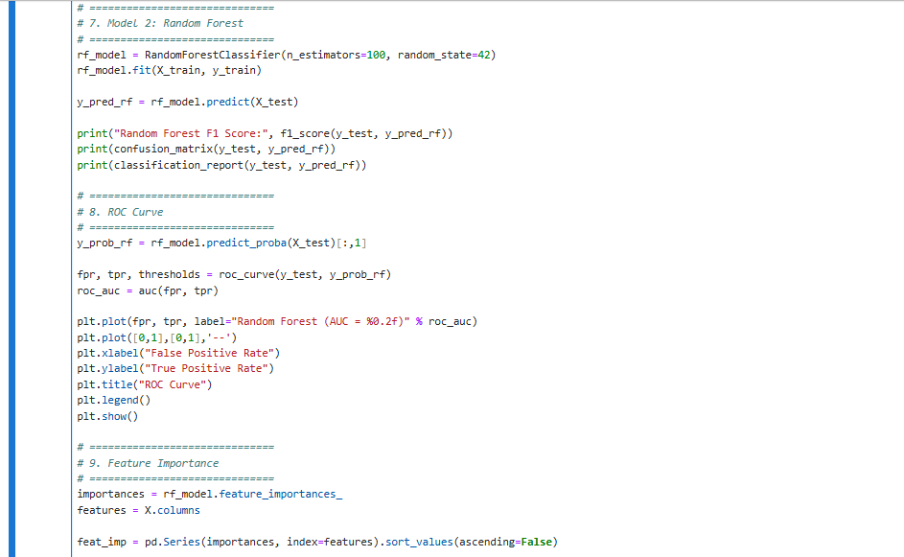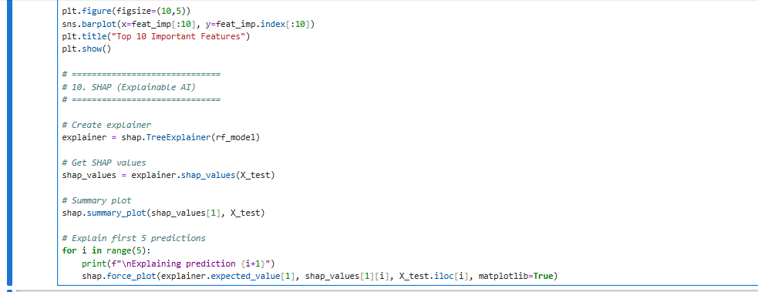

OUTPUT:
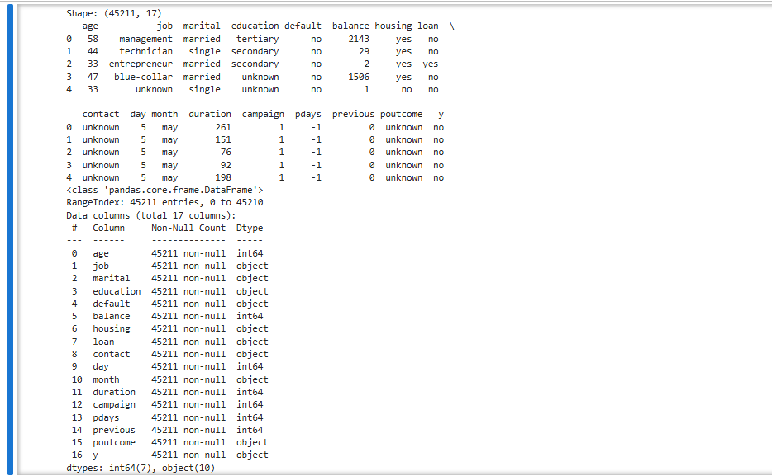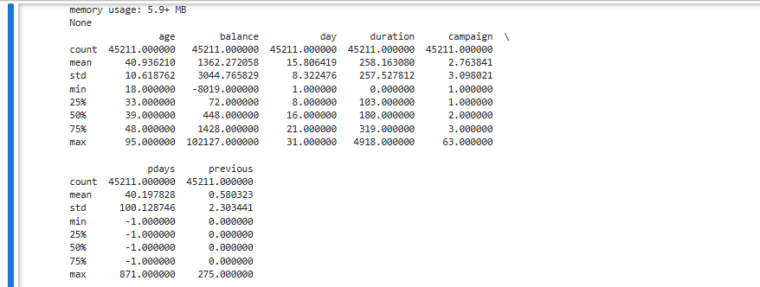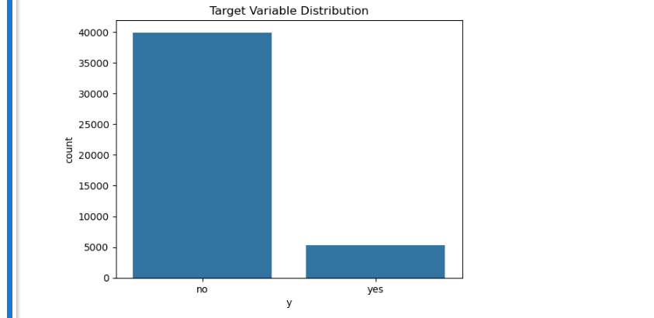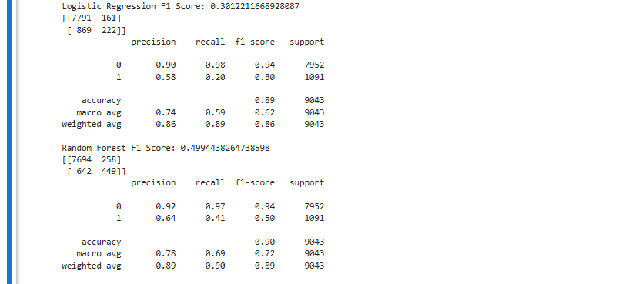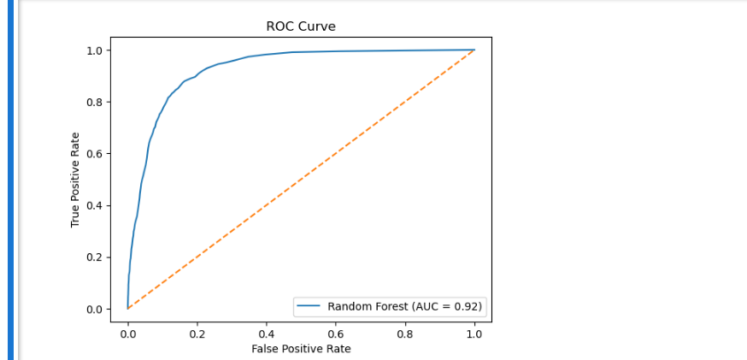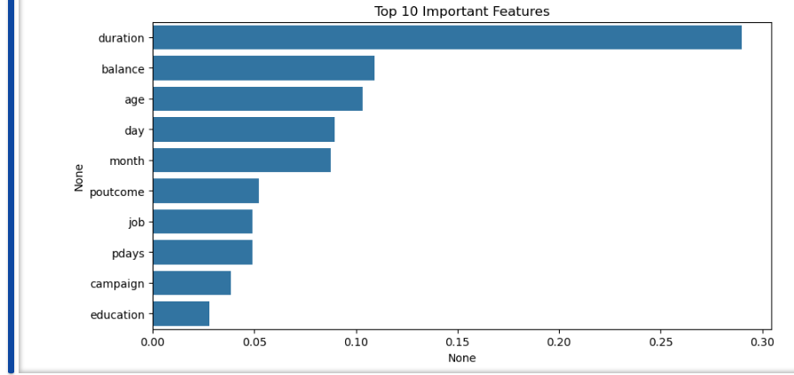

8. Feature Importance
Using Random Forest:
- We identified the most important features affecting predictions
Important features include:
- Duration of contact
- Balance
- Age
- Previous outcome

9. Explainable AI (SHAP)
SHAP (SHapley Additive exPlanations) is used to explain model predictions.
- Shows how each feature impacts prediction
- Helps understand model decisions
- Improves trust in machine learning models

10. Business Insights
From the analysis:
- Customers with higher balance are more likely to accept loans
- Longer contact duration increases acceptance chances
- Certain job types and marital status influence decisions

11. Conclusion
In this task:
- We successfully built machine learning models to predict loan acceptance
- Random Forest gave the best performance
- SHAP helped us interpret the model
This system can help banks:
- Target potential customers
- Save marketing cost
- Increase conversion rate

